**Project 3**

**Tasks**

1.Log into the AWS Management Console.

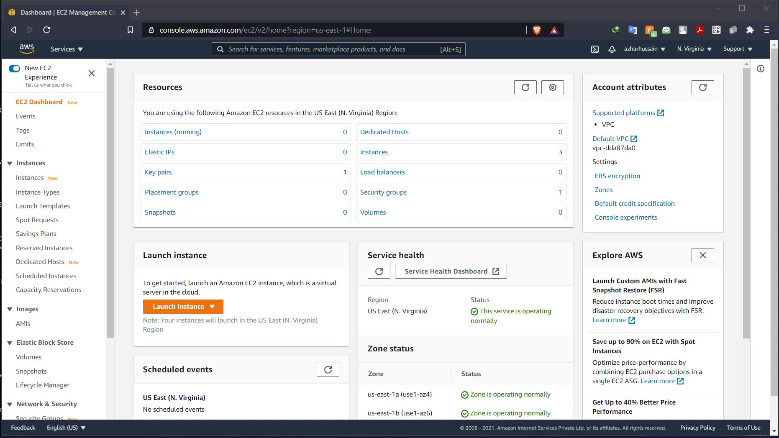

2.Create an IAM Policy and an IAM Role.

- IAM policy created with name mypolicy with json codes

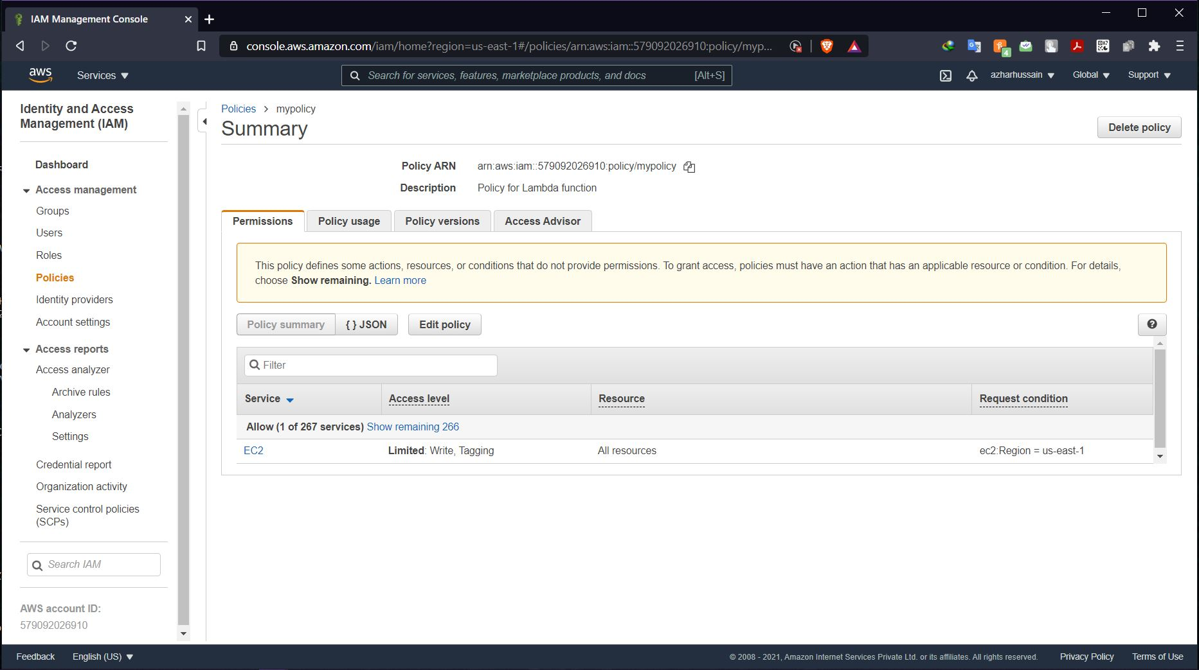

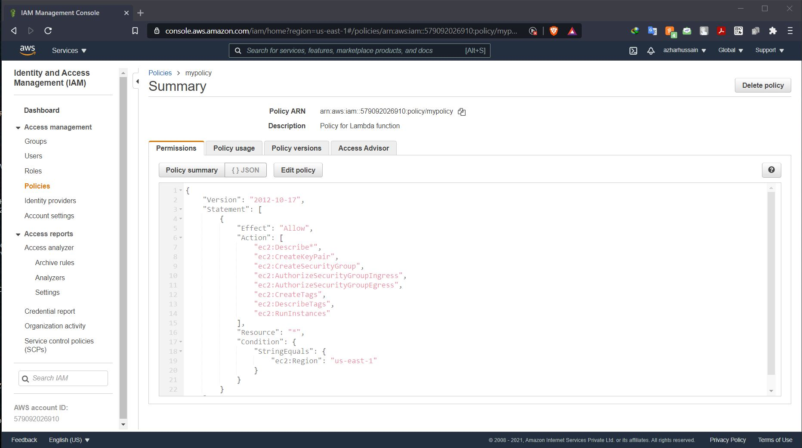

-IAM roles created

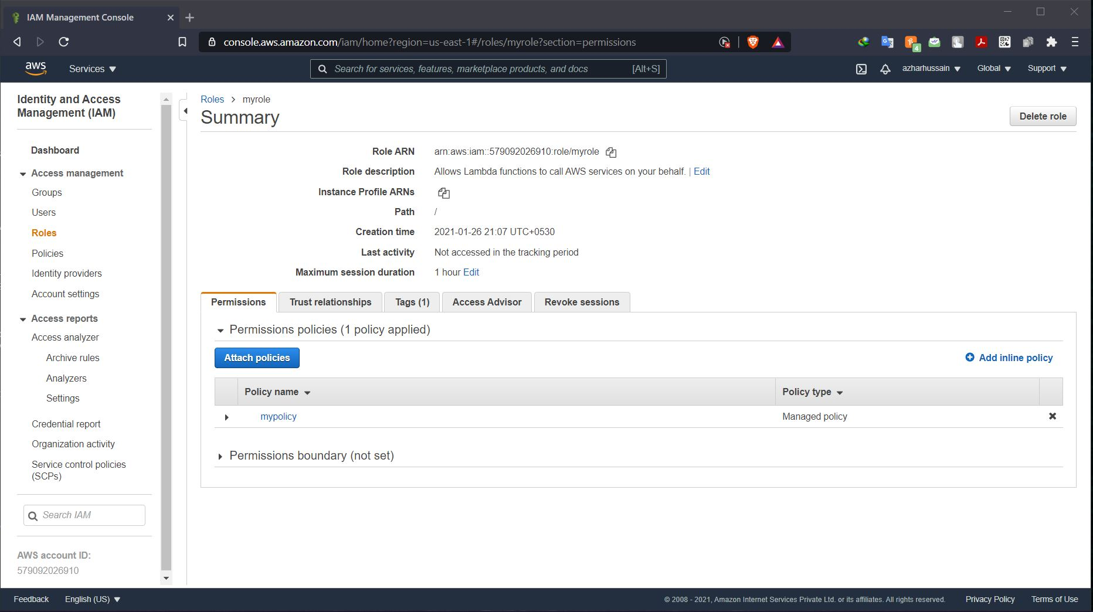

3.Create a lambda function.

- Lambda function created with python codes for an EC2 instance

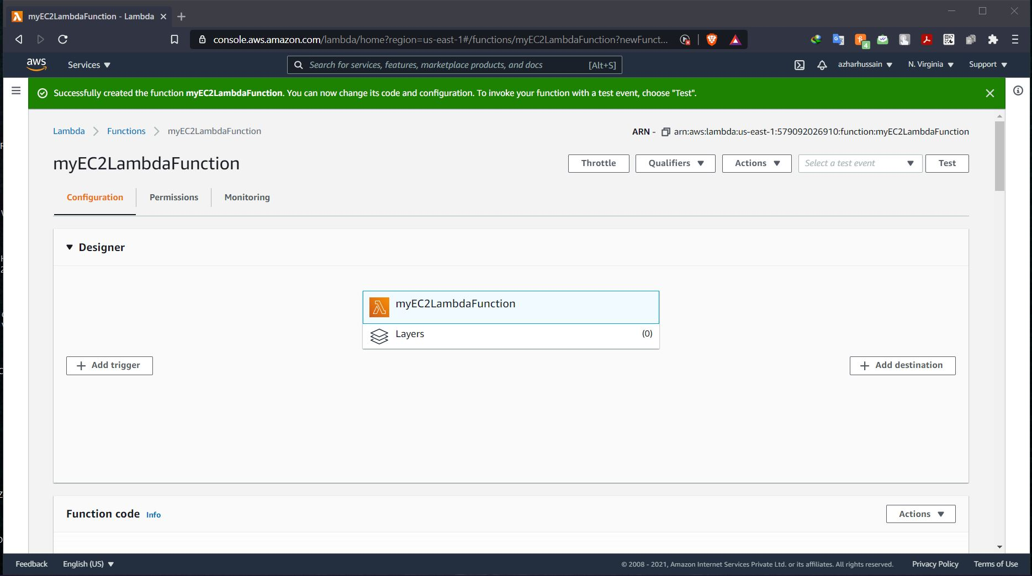

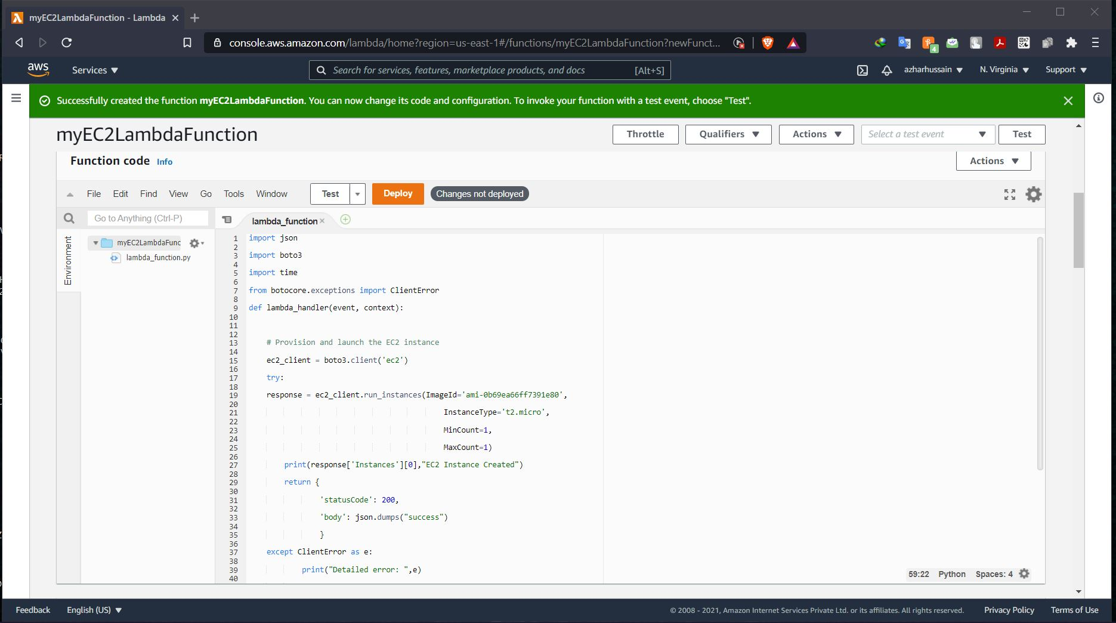

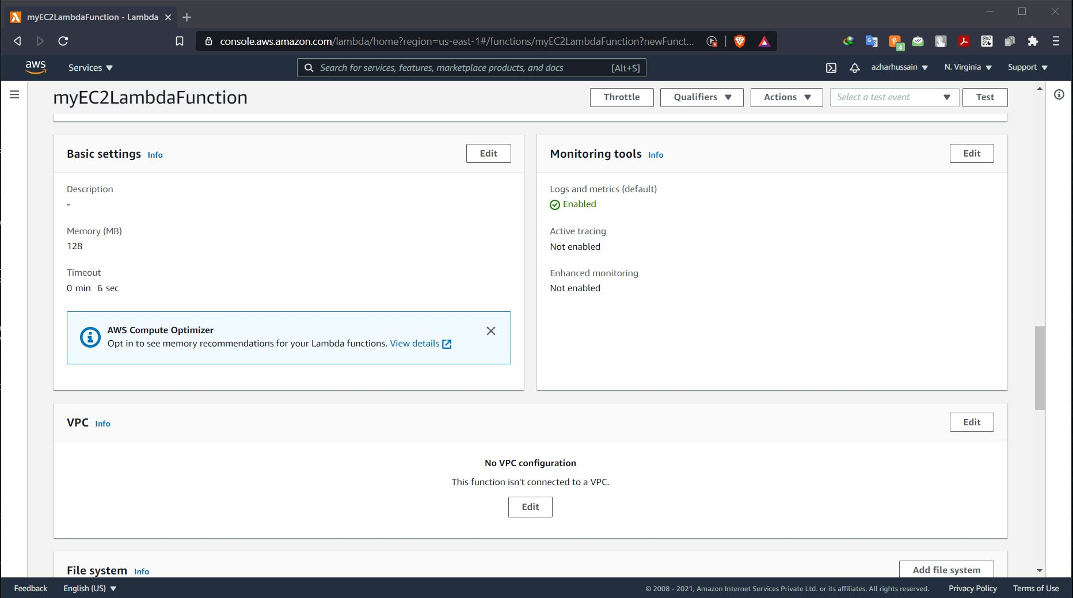

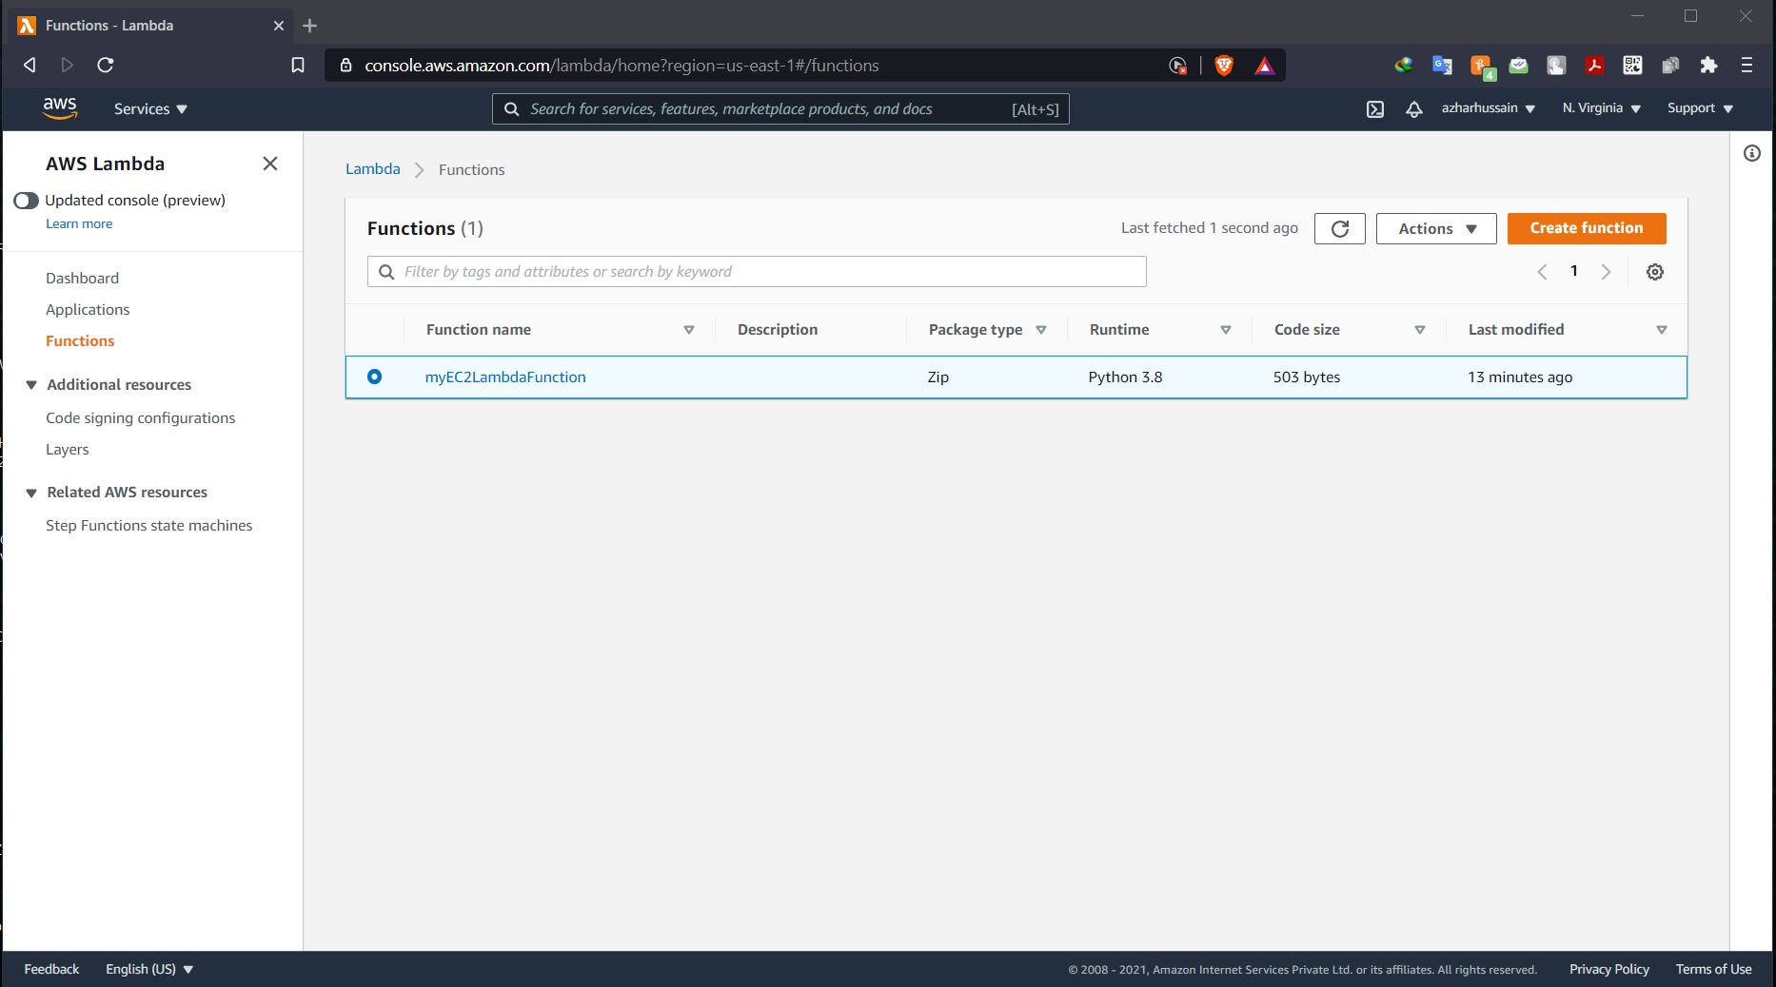

4.Configure a test event.

- a simple test event created for the lambda function

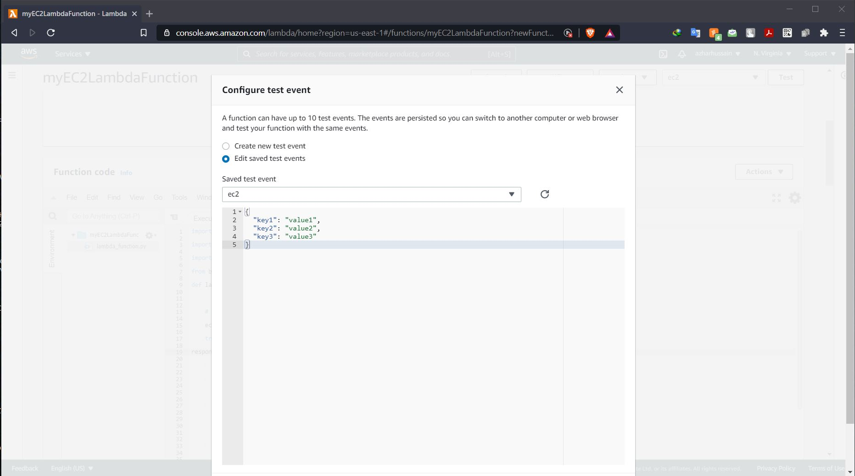

5.Trigger the lambda function manually using the test event.

Test the new EC2 instance.

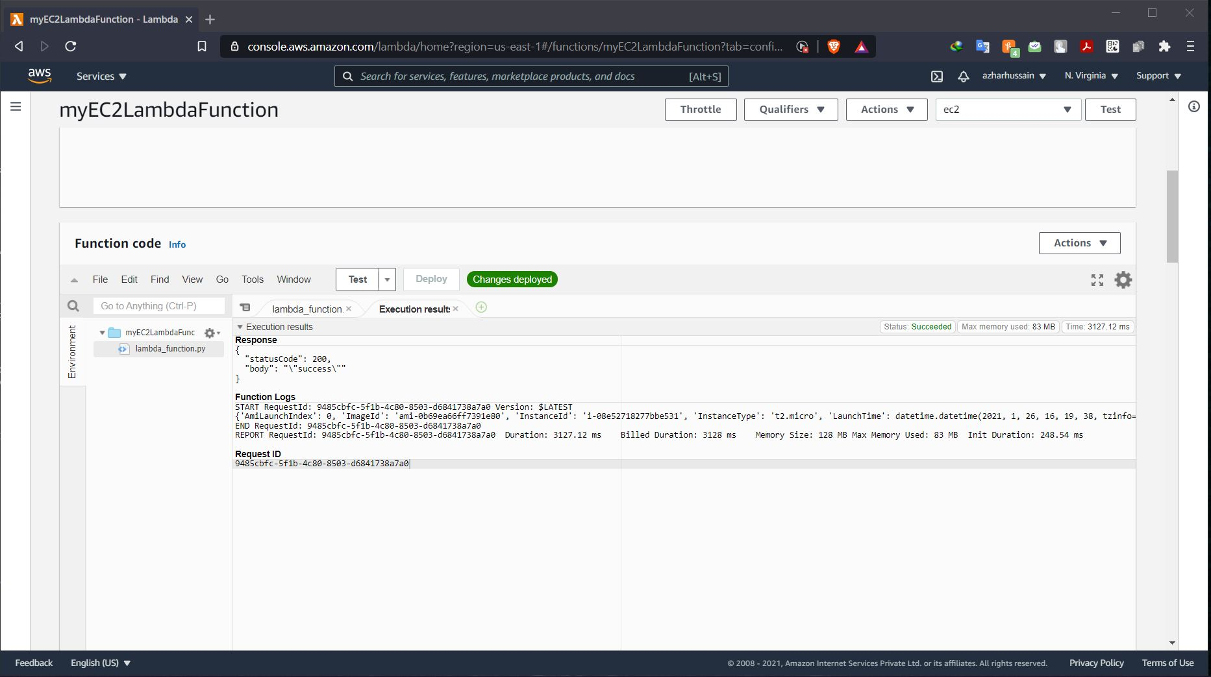

* Successful triggering of the python codes

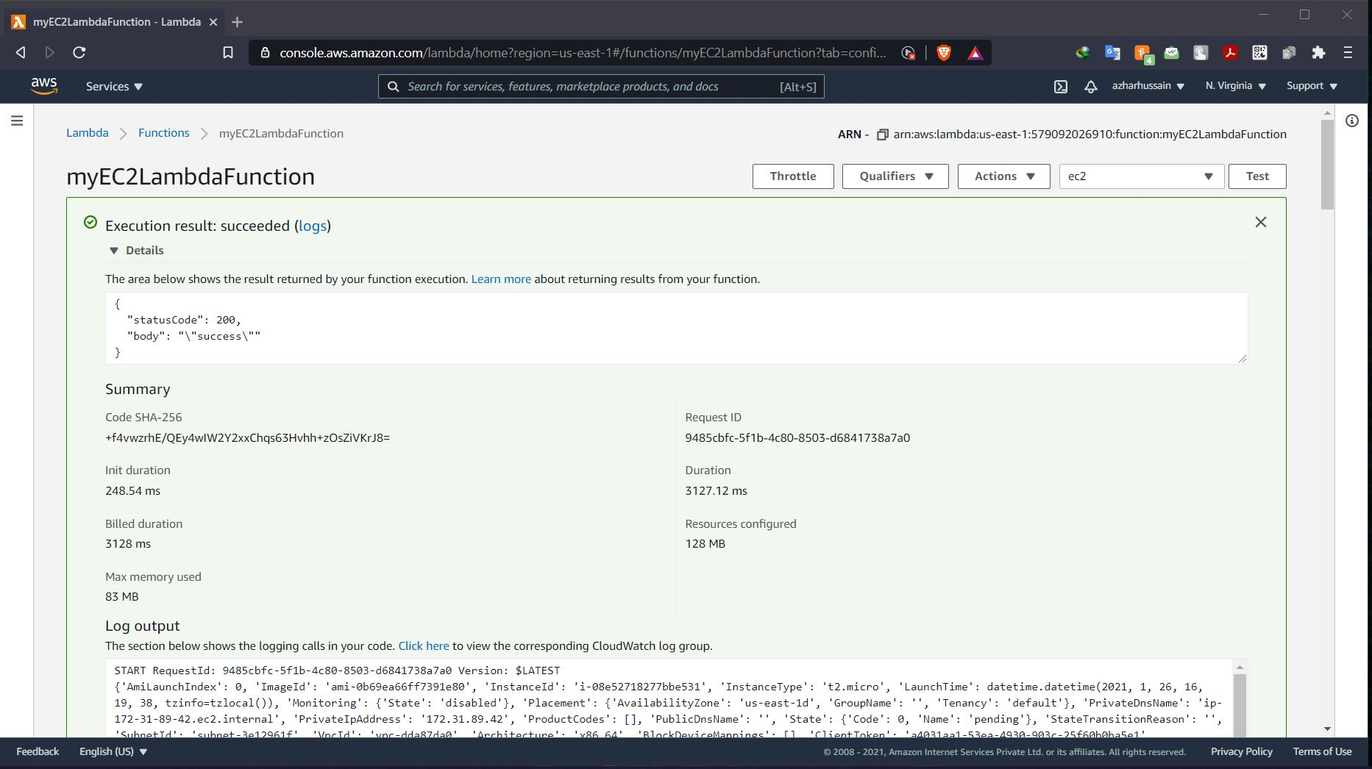

-EC2 instance for the lambda functions

